
Contact

Send you Cv’s to job@mazco.com.sa

Or

Post Box: 2486, Dammam 31451,
KINGDOM OF SAUDI ARABIA.
Tell: +966 3 8260080 EXT: 31
Fax : +966 3 8266618
Website::www.mazco.com.sa

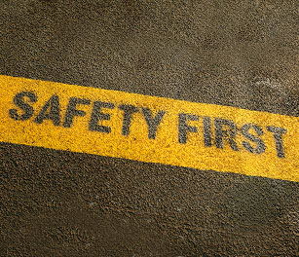
JOB DESCRIPTION
Safety Engineer Shall
- Provide professional advice and technical expertise in identifying and resolving safety issues.
- Perform a range of safety activities to monitor compliance with safety requirements
- support enhanced safety performance and the development of HSE reports
- Execute site visits to audit the safety action plans and monitoring points.
- Provide professional safety engineering advice and technical expertise to support development and optimization of safety policy procedures and programs.
- Collate and validate HSE data for superintendent review to support development of HSE reports.
- Monitor execution of safety training program to support safety competence of own staff and contractor personnel.
- Coordinate and facilitate the monthly RMC site visit and record arising HSE issues to support development of the RMC (HSE) visit report.
- Assist in the implementation of safety strategic plans across the organisation and participates in various activities to identify site safety needs and enhance safety performance.
- Must maintain good relations with the customer departments to elicit open and frank discussion of safety concerns.
QUALIFICATION
- B.Sc. in Chemical Engineering or equivalent.
- Minimum of 6 years’ experience in safety position in the oil/gas industry Or Shift Manager with 3Y Diploma or equivalent and 12 Years’ experience in operations
- Very good English language skills and competent in the use of PC applications (MS Office suite or equivalent)
- Safety Management.
- Regulatory compliance and standards.
- Process knowledge.
- Drive for Excellence.
- Organizational Commitments.
- Good Communication Skill
Safety Engineer

